

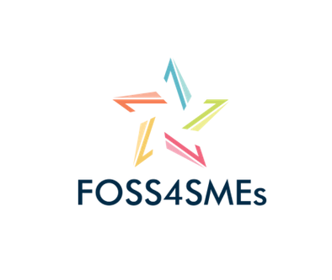

**Project title: Free Open Source Software for SMEs**

Project activity:

FOSS4SMEs Training Course Activity Plan (O2/A1) -

Guidelines for the development of training contents

**Version: 0.2**

**DIT, Ireland**



The European Commission’s support for the production of this publication does not constitute an endorsement of the contents which reflects the views only of the authors, and the Commission cannot be held responsible for any use which may be made of the information contained therein.

Table of Contents

1. Introduction 3

1.1. Output 2 Activities 3

1.2. O2 Deliverables and Timeline 4

2. Course Structure 7

2.1. Overview of the Course and lesson structure 7

2.2. The self-diagnostic tool 8

2.3. The certificate 8

3. Content Structure 8

3.1. Unit Introduction 8

3.2. Lesson Titles 9

3.3. Lesson Content 9

3.3.1. Reading Material: Content as a video 9

3.3.2. Reading Material: Content as text with images 9

3.5. Summarising a lesson 10

3.6. Lesson Activity/Assessment 10

4. Annexes 11

4.1. Examples of lesson content 11

4.2. Template: Content as text with images 12

4.3. Template: Assessment Part 12

4.4. The Training Plan 12

4.x. The Project Timetable 13

# 1. Introduction

Output 2 consists mainly in the development of the e-learning course and the assessment exercises to evaluate and fine-tune the course. The final outcome will be a modular and flexible learning path, available online as free and open educational resource to any interested user. The consortium has already developed the Curriculum of the FOSS Business User within O1, which forms a provisional table of course contents.

The main topics of the course are:

* UNIT 1 INTRODUCING FOSS
* UNIT 2 WHY FOSS IN BUSINESS?
* UNIT 3 WHAT KIND OF FOSS IS AVAILABLE?
* UNIT 4 ADOPTING FOSS IN YOUR BUSINESS
* UNIT 5 (STRATEGIES FOR) MIGRATING TO FOSS

The training course will consider the level of current knowledge of the target audience and the level of migration required (Full Migration, Full Desktop Migration or Partial/Hybrid Migration). In order to make the course immediately applicable and customizable, the consortium will develop a self-diagnostic tool as an entry-point of the course. Per each unit of learning outcome, a quiz will allow learners to test the knowledge acquired and a certificate will be released according to the ECVET profile (O1). The certificate will indicate the learning outcomes, knowledge, skills and competences acquired and associated ECVET credit points.

## 1.1. Output 2 Activities

Due to the complexity of this output, the activities will last 13 months and are grouped as follows:

O2/A1: TRAINING COURSE FOR FOSS BUSINESS USER

Based on the results of the previous output and the design of the profile and associated contents and credits, the consortium will develop training contents, under the coordination of P4-DIT, which will provide the partners with the Training Plan. This activity is the core of the output and will last 6 months. All partners will be involved in contents development based on a task division agreed in advance. However, as reflected in the budget, ATL, DIT, SFSE and SU will have a primary role.

O2/A2: TRANSLATION

The course will be first developed in English and then translated into national languages.

O2/A3: FOSS4SMEs PLATFORM

The development of the platform is the responsibility of P1-ATL, who will make use of open source tools for e-learning solutions. The distant learning platform chosen is Moodle, which will be fully customized to the needs of the project and the course, in addition to best practice aesthetics and UI. The platform will host the training courses as a distant learning resource but will also allow for download of materials in the form of pdf documents. The platform is hosted on the website of the course under: <http://www.foss4smes.eu/moodle/>

O2/A4: FOSS4SMEs ASSESSMENT

The assessment of results will be carried out in two steps. First, the partners will conduct short training activities at local level, exploiting also the occasion of multiplier events, in order to ask the representatives of the target group (15 per country) their opinion about the entire training system. The partners’ staff will be available as tutors online during the assessment activities (one hour per day during a date/time agreed upon by the partners). Leveraging the partners international networks, it is also envisaged to involve SMEs from other EU countries. However, each partner will also involve one VET provider to test the applicability and exploitability of the course within the VET sector at local level. P6-SU will coordinate this phase: it will provide methodology and tools for the assessment, according to the indicators and the general framework for evaluation described in the quality plan by DLEARN.

O2/A5: FINAL RELEASE

Based on the results of the assessment, the platform and courses will be evaluated and improved (if needed), in view of the final release.

## 1.2. O2 Deliverables and Timeline

The deliverables of O2 that will be uploaded in the Mobility Tool for the control of the NA are:

1. The Guidelines for the development of training contents
2. The Training Plan
3. The Course Contents in English
4. The Course Contents translated into the national languages (Gr, Se, It and De)
5. The Design plan for the distant learning platform
6. The Training Platform with the imported course contents
7. The Methodological Framework with tools for the assessment
8. The Report on a. the results of the short training activities and b. the results of the VET providers tests on the applicability of the course

In relation the development of the contents and which partner will deliver which Unit the team agreed on the following task division within O2/A1:

Unit 1: ATL

Unit 2: OFE and Dlearn

Unit 3: DIT

Unit 4: SKUNI

Unit 5: FSFE

ATL, DIT, FSFE and SKUNI have a primary role in the content development, while Dlearn and OFE have a secondary role and less working days assigned. Unit 1 and 2 should be prepared by 15.09.18, while the rest of the Units can be prepared by 30.11.18. The final deadline for the training content development is 21.12.18 before Christmas time.

| **N.** | **Activity** | **Deliverable/ Task** | **Role** | **Respon.** | **Deadline** | **Eval.** | **Dis. Lev** |
| --- | --- | --- | --- | --- | --- | --- | --- |
| **Output 2 – Activity Leader: DIT** | | | | | | | |
| **24** | O2/ A1 Training course contents  01.07. – 31.12.18 | „Development of modular training contents with self-diagnostic tools in English” | **Leader: DIT** | Coordinate | 11.18 | DIT |  |
|  | Reference Document – Guidelines for the development of training contents | DIT | Prepare | 07.18 | DIT |  |
|  | Training Plan | DIT | Prepare | 07.18 | DIT |  |
| **25** | Content development Unit 1 | ATL | Prepare | 11.18 | DIT |  |
| **26** | Content development Unit 3 | DIT | Prepare | 11.18 | DIT |  |
| **27** | Content development Unit 5 | FSFE | Prepare | 11.18 | DIT |  |
| **28** | Content development Unit 4 | SU | Prepare | 11.18 | DIT |  |
| **29** | Content development Unit 2 | OFE | Prepare | 15.09.18 | DIT |  |
| **30** | Content development Unit 2 | Dlearn | Prepare | 15.09.18 | DIT |  |
| **31** | Peer review and finalisation | Peer Review Committee | Review | 12.18 | FSFE, OFE |  |
| **32** | O2/ A2 Translation  01-30.01.19 | Translation in Greek | ATL | Prepare | 12.18 | ATL | CO |
| **33** | Translation in Swedish | SU | Prepare | 12.18 | SU | CO |
| **34** | Translation in German | FSFE | Prepare | 12.18 | OFE | CO |
| **35** | Translation in Italian | Dlearn | Prepare | 12.18 | Dlearn | CO |
| **37** | O2/ A3 FOSS4SMEs Platform  01.12.18 – 30.02.19 | Design plan for the distant learning platform | **Leader: ATL** | Create | 01.19 | ATL |  |
| **38** | Development and customisation of the platform | ATL | Develop | 01.19 | ATL |  |
| **39** | Content import and management support | ATL | Import | 01.19 | ATL |  |
| **40** | Testing | ATL | Test | 01.19 | ATL |  |
| **41** | Peer review and finalisation | Peer Review Committee | Final test | 01.19 | FSFE, OFE |  |
| **43** | O2/ A4 FOSS4SMEs Assessment  01.03. – 30.06.19 | Methodological Framework with tools for the assessment | **Coordination: P6 – SU** | Prepare and coordinate | 02.19 | QM |  |
| **44** | Short training activity in GR | ATL | Conduct | 03.19 | tr. participants | PU |
| **45** | Short training activity in IR | DIT | Conduct | 03.19 | tr. participants | PU |
| **46** | Short training activity in DE | FSFE | Conduct | 03.19 | tr. participants | PU |
| **47** | Short training activity in SE | SU | Conduct | 03.19 | tr. participants | PU |
| **48** | Short training activity in the UK | OFE | Conduct | 03.19 | tr. participants | PU |
| **49** | Short training activity in IT | Dlearn | Conduct | 03.19 | tr. participants | PU |
| **50** | VET provider tests applicability of the course in GR | ATL | Organise | 05.19 | GR VET provider | PU |
| **51** | VET provider tests applicability of the course in IR | DIT | Organise | 05.19 | IR VET provider | PU |
| **52** | VET provider tests applicability of the course in DE | FSFE | Organise | 05.19 | DE VET provider | PU |
| **53** | VET provider tests applicability of the course in SE | SU | Organise | 05.19 | SE VET provider | PU |
| **54** | VET provider tests applicability of the course in UK | OFE | Organise | 05.19 | UK VET provider | PU |
| **55** | VET provider tests applicability of the course in IT | Dlearn | Organise | 05.19 | IT VET provider | PU |
| **56** | O2/ A5 Final Release  01-30.07.19 | Evaluation of the e-learning platform | ALL | Conduct | 05.19 |  | CO |
| **57** | Evaluation of the courses | ALL | Conduct | 05.19 |  | CO |
| **58** | Improvement of the platform and the courses | ALL | Conduct | 06.19 |  | CO |
| **59** | Final release | ALL | Conduct | 06.19 | PM, QM, MC; FSFE, OFE | PU |

In relation to the role of ATL leading within O2 (**O2/ A3 FOSS4SMEs Platform** 01.12.18 – 30.02.19), the agreed internal timeframe for the development of the platform is as follows:

* By 07.18 ATL checks available platforms and decides on one. ATL agrees with DIT and the team on this.
* By 10.18 ATL prepares the Design Plan for the platform, development and customisation.
* By 01.19 ATL conducts content import and testing
* By 02.19 ATL inserts available translations and finalises the platform
* By 03.19 ATL is testing the applicability of the Greek course with Greek VET providers
* In 05.19 ATL uses the platform in the Multiplier Event in Thessaloniki, Greece
* By 06.19 ATL evaluates the platform
* By 07.19 ATL improves the platform and the courses for the final release

# 2. Course Structure

As outlined by the application and highlighted in the MCE Plan (MCE Plan_20180704_v.09) a major objective of the project is to develop a training course to European SMEs in order to develop Free and Open Source Software (FOSS) knowledge and skills. The aim of the training course will be to raise awareness about the nature of FOSS and to develop confidence skills in using FOSS for a particular business user (BU) requirements. To achieve this goal, a FOSS BU competence profile has been developed in the previous activity (O1) which contains a number of specific Units with associated learning outcomes.

Based in the previous outputs the training contents will be developed based on the training plan as outlined in this document and associated templates. The training course that our team is developing will correspond to 1 ECVET point which equals 25 hours in total for the whole training, meaning 5 hours per Unit and 1 hour approximately per lesson. Therefore each partner will develop a basic introductory part for the Unit of his responsibility.

This activity is the core workload from Output 2 and It will last 6 months. The content will be developed by all consortium partners as per the agreed workload (see chapter 1.2). Peer reviewers for this activity are FSFE and OFE.

## 2.1. Overview of the Course and lesson structure

The purpose of this chapter is to provide guidelines on how the training course should be structured in order to maintain consistency across each of the units and lessons. The guidelines should be viewed as recommendations for a generic unit and lesson which may be adapted to suit the particular needs of each unit or lesson. The contents developed will be transferred to the learning platform which will dictate the style and final layout of the content. This document will provide guidelines on what type of content is required.

Major content of a lesson will consist of the following (see Annex 1 for an example):

* Lesson Title heading
* Lesson Introduction
* Video recordings
* Reading material
* Imagery
* Small Quiz / assessment
* Small Summary

The translations of the Units and their lessons will be provided for each of the recognised languages as laid out in the MCE Plan. The contents should be ready for translation by the end of December 2018 before the transnational project meeting held in Dublin.

The following documents were created to develop the associated content for each unit and its lessons.

* [FOSS BU Competence Profile](https://goo.gl/BYQBgQ) (BCP) (<https://goo.gl/BYQBgQ>)

The BCP has been completed by each of the members during O1/A2 and can be used as a reference for content development.

* [Curriculum Development Plan](https://goo.gl/4Ns7eQ) (CDP) (<https://goo.gl/4Ns7eQ>)

The CDP will be used to keep track of the progress of each of the Units, indicating which items have been completed. The major parts required for completion before the meeting in Dublin are as follows:

* Lesson Content
* Slides updated with artwork
* Script and Prompt Notes

These items must be completed by the end of December 2018 to ensure that the video content can be recorded during the Dublin meeting. Further information will be provided on how best to generate video content through examples provided by DIT.

## 2.2. The self-diagnostic tool

The self-diagnostic tool will serve as a guide within the learning path: the learner, by answering simple questions related to the sector of activity, the areas of interest, the initial level of knowledge of FOSS and the specific software already in use, will be directed to the relevant training materials. The learner, thanks to the self-diagnostic tool, will be guided through the contents available, be informed about the possible solutions offered by FOSS and take single courses or the entire learning pathway.

## 2.3. The certificate

A certificate will be released according to the ECVET profile (O1), describing learning outcomes, knowledge, skills and competences acquired and associated ECVET credit points.

# 3. Content Structure

The following are guidelines on content requirements to be included on the learning platform along with suggested word counts. This will be the basic structure for each unit developed.

## 3.1. Unit Introduction

|  |  |
| --- | --- |
| **Unit Title:** |  |
| *Introductory text explaining what the unit is about. This should include a description of the content type, the major lesson consents and associated quiz.*  [approximately 600 characters] | |
|  | |

## 3.2. Lesson Titles

The list of lessons which will be undertaken in this unit. The list will be used for consistency when indexing the units and lessons in the learning platform hierarchy.

|  |  |
| --- | --- |
| **Unit** | *Unit Name* |
| **Lesson No.** | **Lesson Title** |
| ***L1*** | *Title 1* |
| ***L2*** | *Title 2* |
| ***L3*** | *Title 3* |
|  |  |
|  |  |

## 3.3. Lesson Content

The lesson content will contain a combination of reading material and rich media. The development of the rich media will be guided by DIT through examples of best practice. The content for video material must be scripted in advance along with any necessary slide and artwork. Lesson content for video material will differ from reading material as the emphasis will be on the speaker delivering the content. Therefore the reading material will require sufficient detailed description of each lesson for the learner to achieve the learning outcomes.

It is recommended that content should be scenario based and should consider the current level of knowledge of the learner and the level of migration to FOSS required. The three main scenarios set out are Partial/Hybrid Migration, Desktop Migration or Full Migration.

The lesson should include scenarios relating to these migration plans e.g.

* *A small shop may be interested in a partial migration or in particular in a FOSS alternative to manage mailing and accounting;*
* *A consulting company or a communication agency may be more interested in CRM software;*
* *An innovative engineering start-up may be willing to uptake a full migration to FOSS including the Operative System and all supportive productivity software.*

The lesson should address the prior knowledge expectation of the learner and guide them toward a solution for a FOSS alternative.

## 3.3.1. Reading Material: Content as a video

Any video material should have supporting text to describe the video [approximately 200 characters].

## 3.3.2. Reading Material: Content as text with images

Content should be accompanied by images that support the text. This is in line with best practices for people with certain learning difficulties and servers the additional purpose of breaking up the text. Images should be copyright free used from a standard library where possible[1]. Images should be optimised to minimise loading times and should be of sufficient quality and clarity to enable viewing on a standard high resolution desktop. Guidelines for best practice regarding web readability can be found [here](https://usabilla.com/blog/8-guidelines-for-better-readability-on-the-web/). Reading content should be limited to one major topic per slide/screen and be approximately 1500 characters. Where a topic needs to be extended, this should be transitioned within the same slide/page.

## 3.5. Summarising a lesson

Each lesson will be closed out with a brief summary of the topic covered. The summary text may be accompanied by an image/diagram.

|  |
| --- |
| *A description of what the learner has covered including the main knowledge and skills gained.*  [approximately 600 characters] |
|  |

## 3.6. Lesson Activity/Assessment

In order to engage the learner in the lesson as they progress there will be a quiz activity at the end of the section. The format of the quiz is going along by the technology available in the Moodle platform. The available formats for question types are:

* Choosing the right answer
* Choosing the right sentence
* Multiple correct answers
* Selecting the right option

For simplicity a series of multiple choice questions could be asked. For each question a correct answer and at least one incorrect answer should be provided. The learner should be provided with feedback after they have made their selection.

|  |  |
| --- | --- |
| Question: *Brief question preferably scenario based. [200 characters]* | Mark Correct |
| Answer 1 | Yes/No |
| Answer 2 | Yes/No |
| Answer 3 | Yes/No |
| Feedback: |  |

# 4. Annexes

## 4.1. Examples of lesson content

This is an example of an introductory part of a lesson within a Unit. An introductory part can be placed in the beginning of a lesson informing the user what will be done within the relevant lesson.

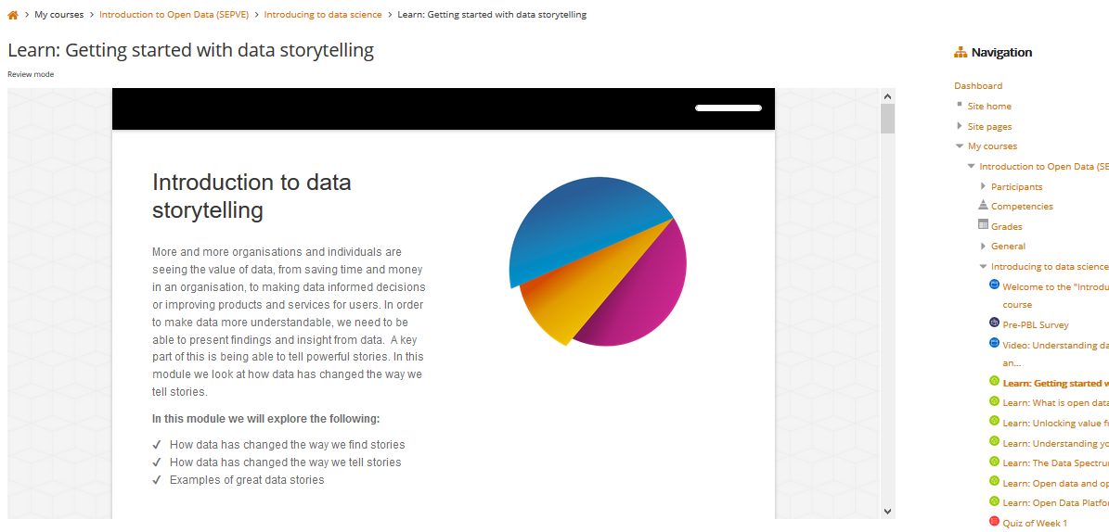

This is an example of lesson content as a reading text with a picture to the side.

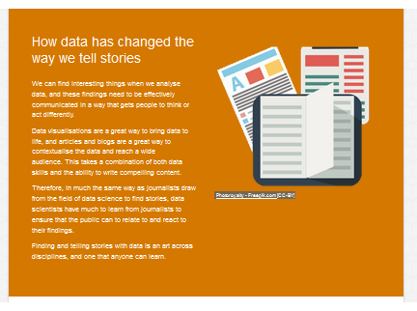

This is an example of an assessment at the end of a lesson.

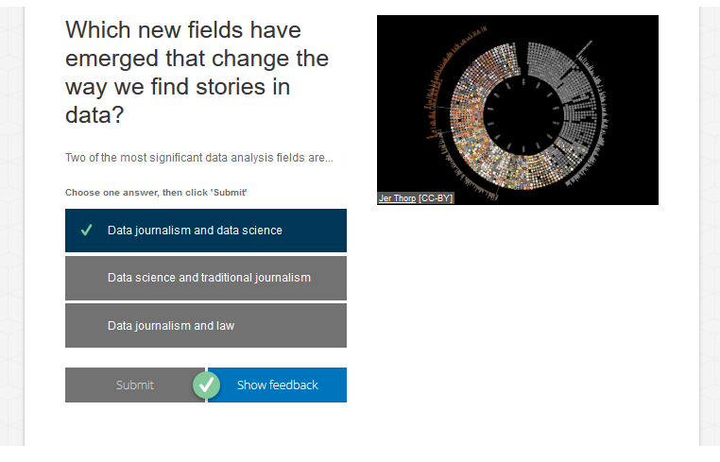

## 4.2. Template: Content as text with images

The following table is a layout and structure explaining the way that all partners should deliver their content for their respective lessons. The partners are free to choose how to structure their lessons, meaning where to put an image, a text part, etc.

Lesson x: Title heading

|  |  |
| --- | --- |
| Image 1 | Text Part 1 (Introduction Part) |
| Image 2 | Text Part 2 |
| No Image | Text Part 3 |
| Text Part 4 | Image 3 |
| …. | …. |
| Standard image for Quizzes/ assessments | Assessment text |
| Standard image for summary | Summary text |

## 4.3. Template: Assessment Part

## 

## 4.4. The Training Plan

## 

## 4.x. The Project Timetable

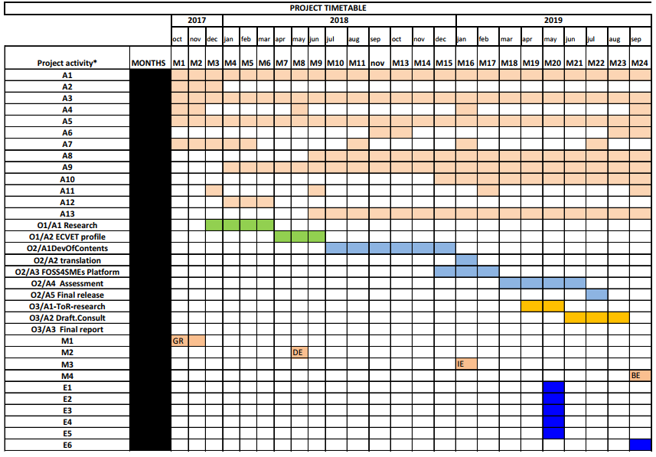

1. For example: <https://www.pexels.com/>