In the unit we want we press Turn Editing On

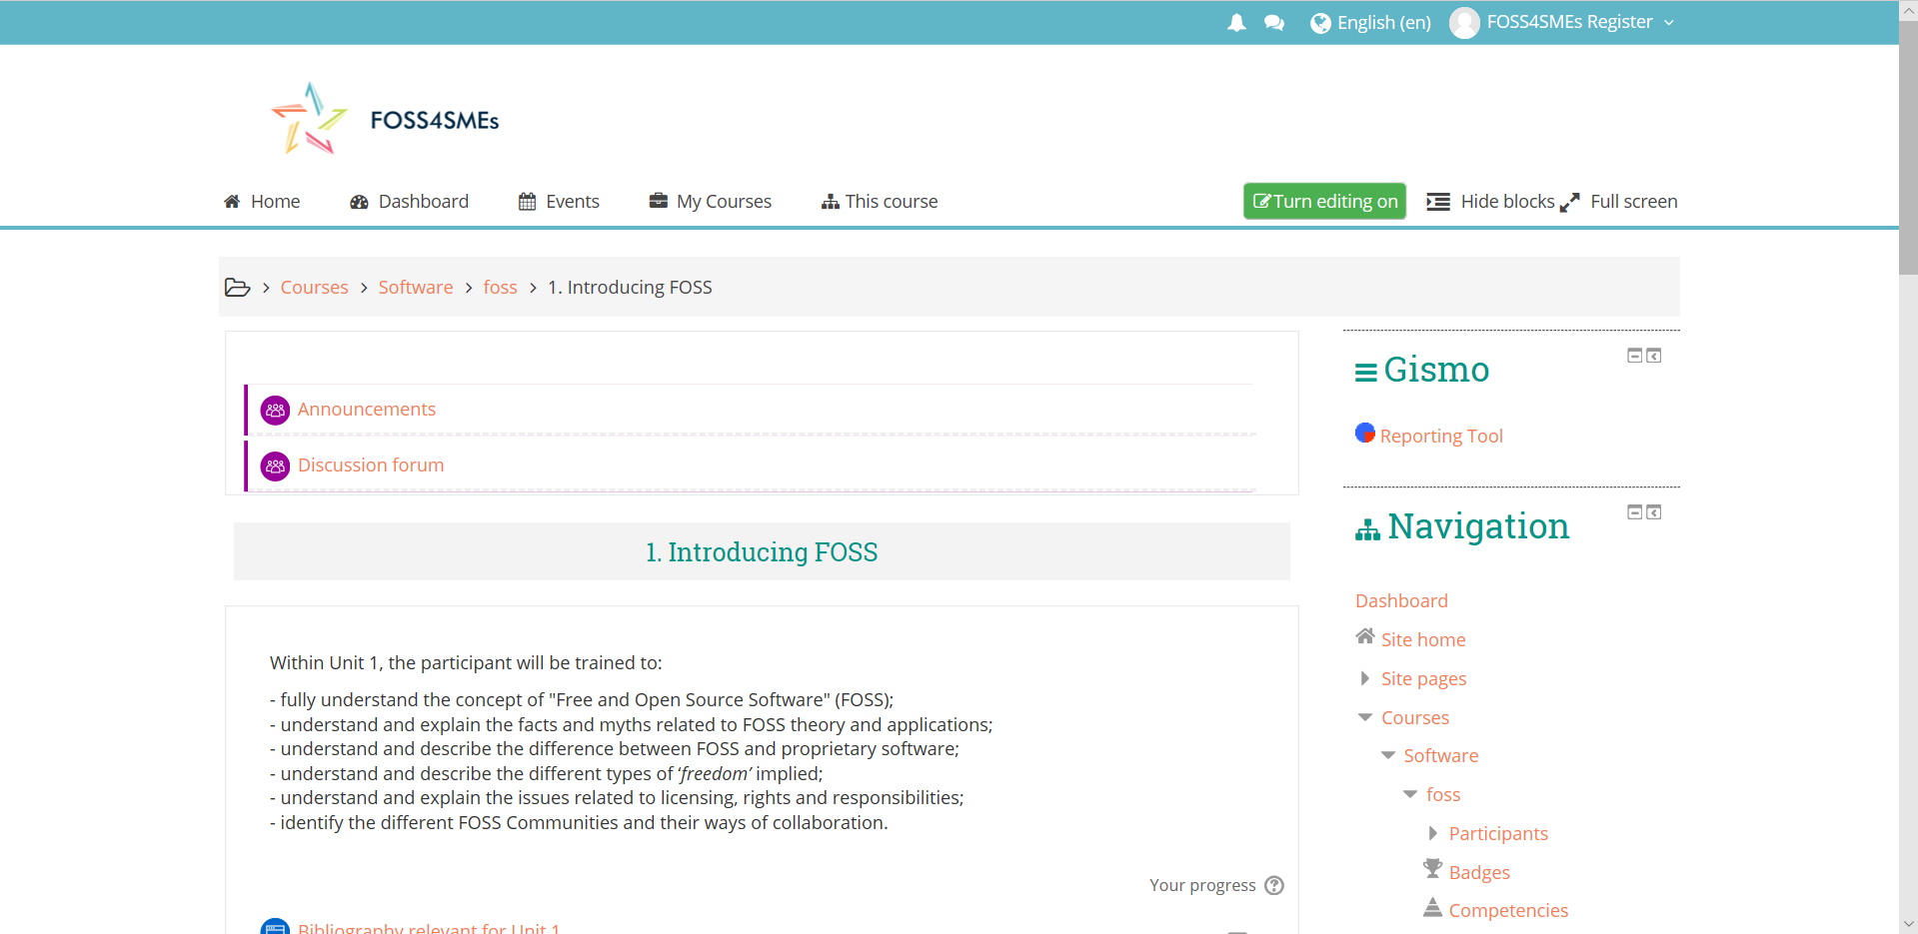

If we want to edit an existing activity inside the Unit:

If it is a page: We press on the edit button and then Edit Settings

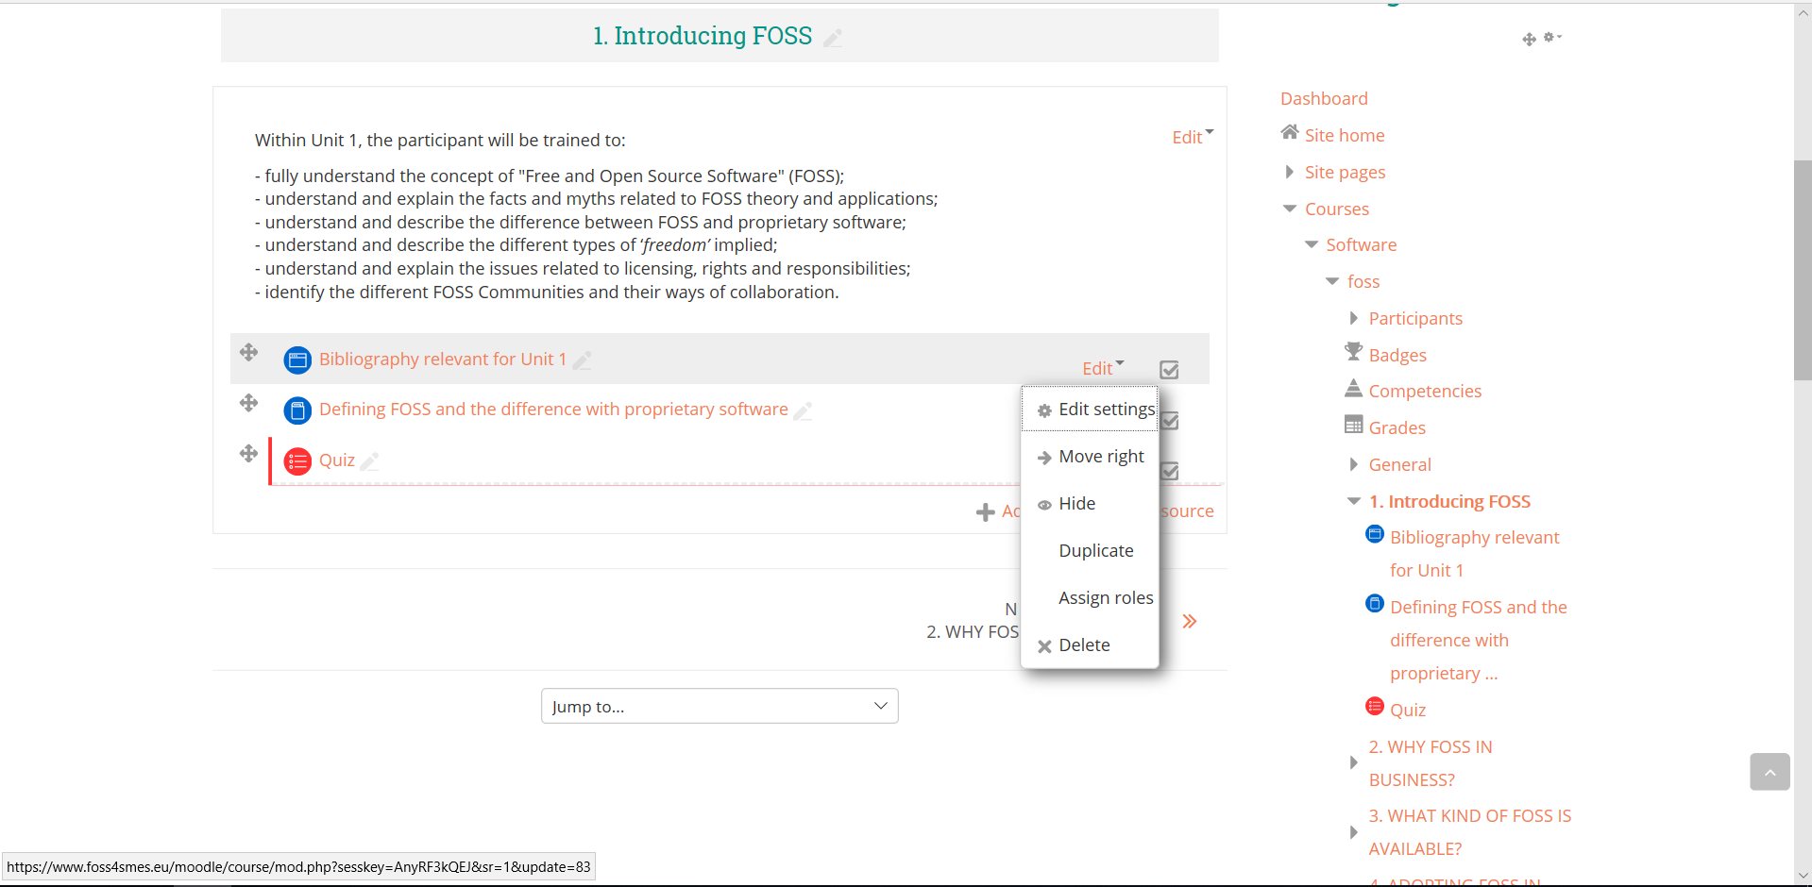

If it is a book we press in the name and we go to this page where on the right the are all the chapters:

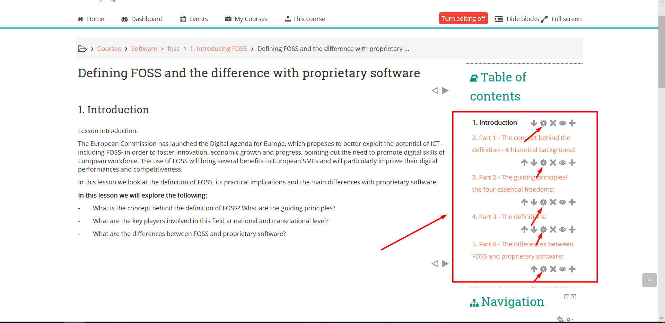

If we want to edit any chapter we press on the small arrow that is shown in the image.

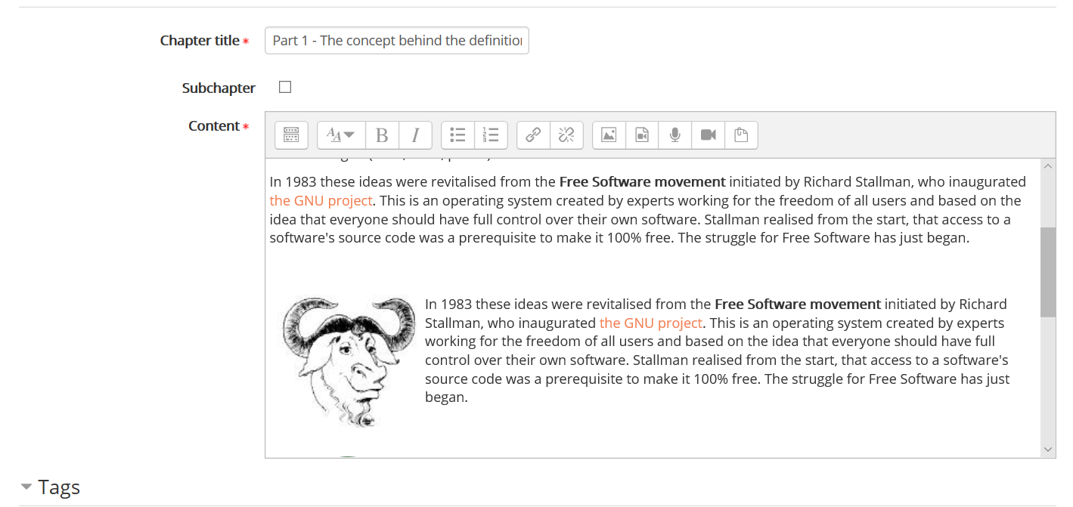

Then it opens the text editor where we can edit the chapter.

Code for image next to text:

**In the src we write the path to the image…**

<div style="clear: left;">

<p style="float: left;"><img width="150" height="228" class="img-responsive atto_image_button_text-bottom" role="presentation" alt="" src="https://opensource.org/files/osi_standard_logo.png"></p>

<p><span lang="EN-GB">we write text here…</span></p>

If it is a quiz we press on the name of the quiz and then on **Edit Quiz** in the right sidebar:

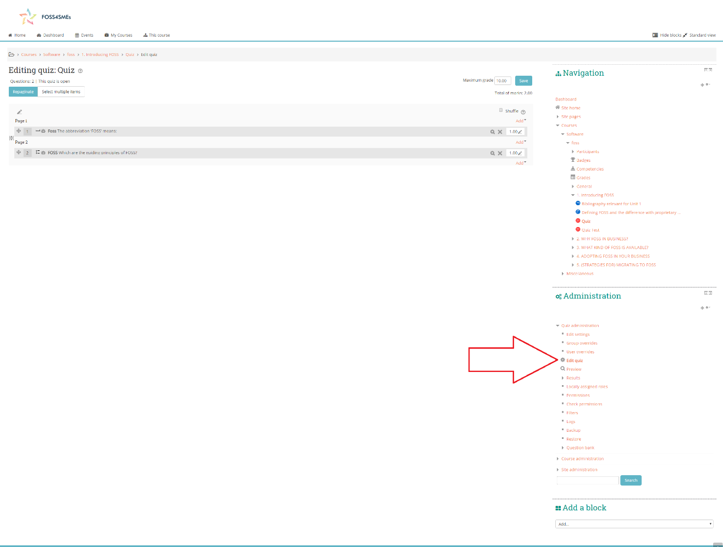

Then either we press on the name of the question (to edit an existing question) or we press on the add -> A new question to add a new question.

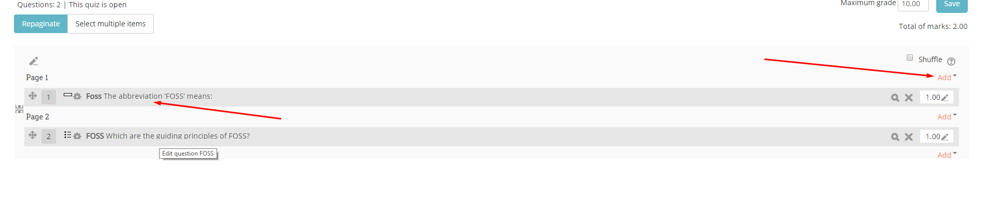

To add a new question:

1. We select the type of question that we want

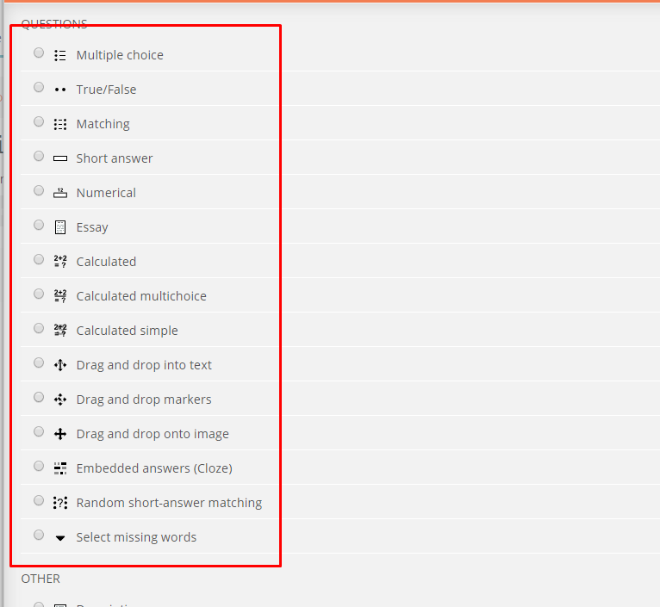

1. If it is a True/False question, we fill in this information with:

* Question Name
* Question Text (The question that we want to ask)
* We choose if the question is ‘True’ or ‘False’
* We can add an extra text when the users answers ‘True’ or ‘False’ (like on the screenshot below where A message that will…. Appears.

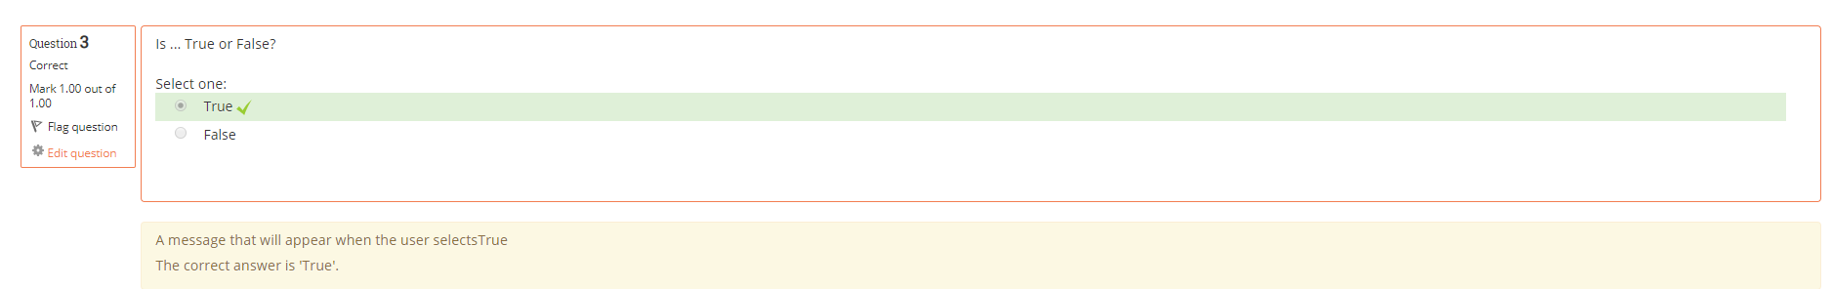

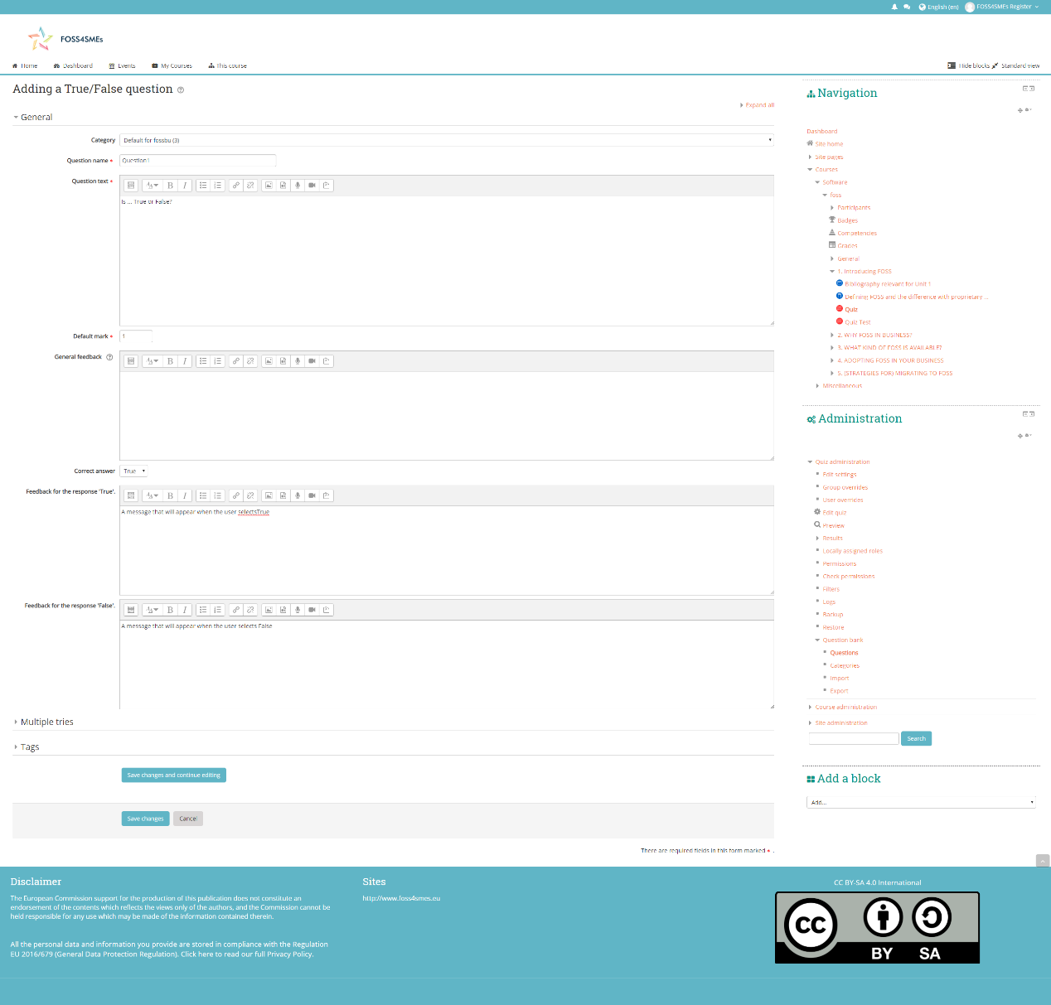

1. We press Save changes to save.

If it is a Multiple Choice:

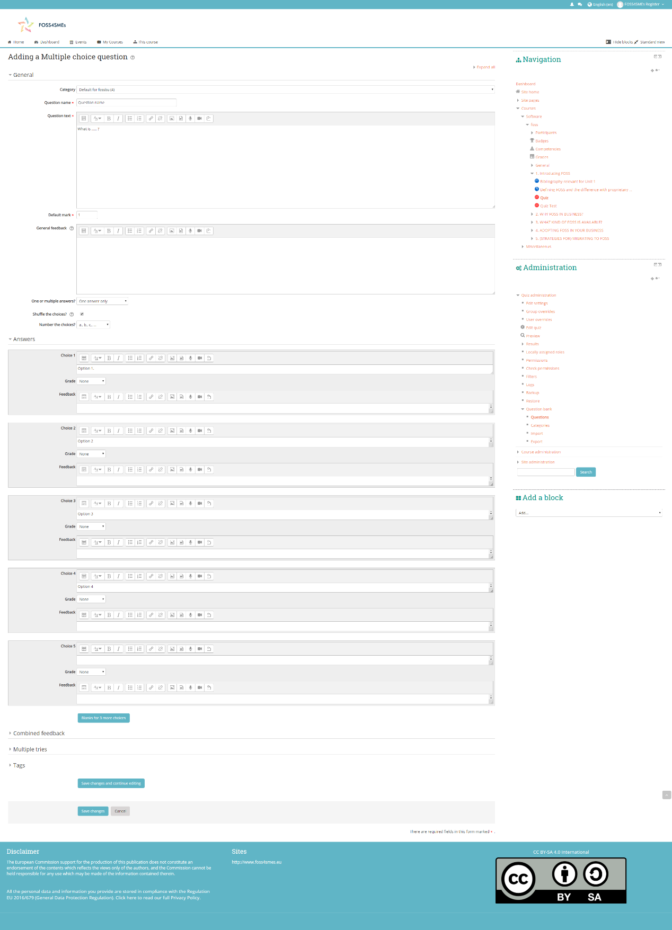

We fill in:

* Question Name
* Question text (What the question is)
* Choice ‘…’. The text of the choice.
* Grading (As explained Below)

Grading:

For grading, if only one option is correct we select 100% to that question and 0 to the others. Else we divide the 100 to the amount of correct answers for example if there are 2 correct we choose 50 and 50 to the correct answers.

If we want to create a new activity:

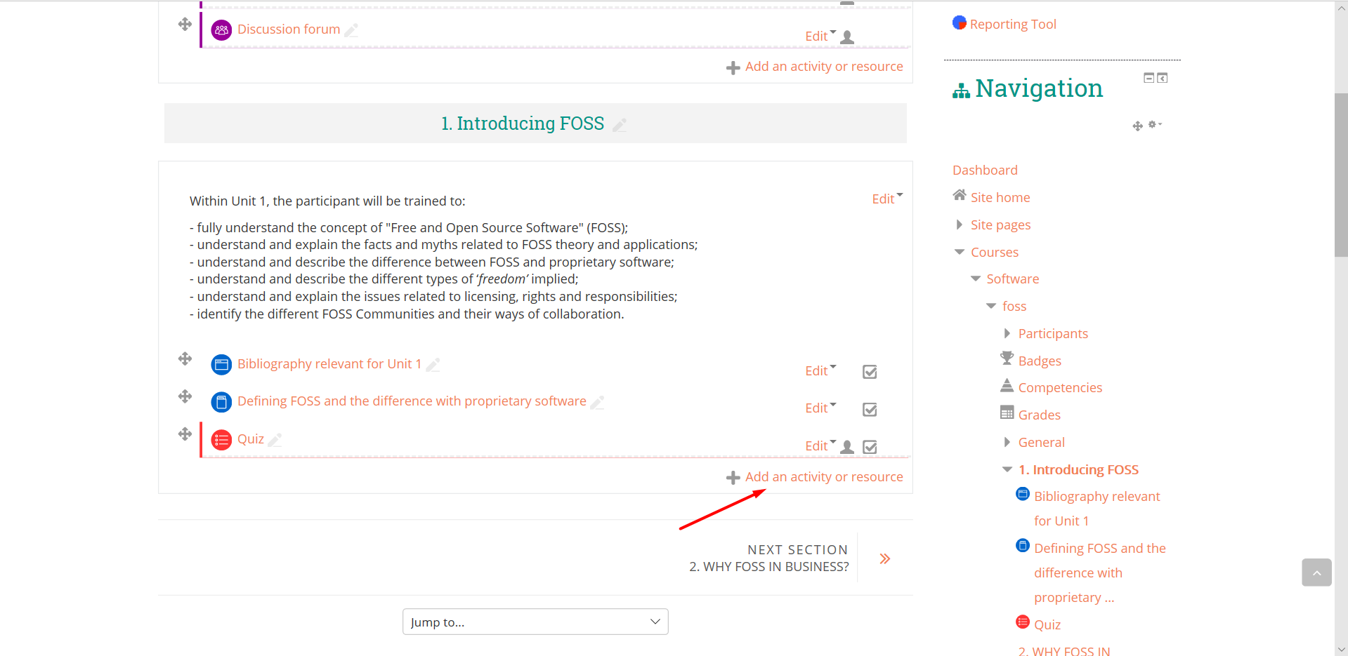

We press Add an activity or resource where we can choose between:

* Page (A single page)
* File (We can upload a file) (For example a ppt or doc)
* Book(Multiple pages/chapters)
* Label(It will say something but it cannot be clicked to go to another page)

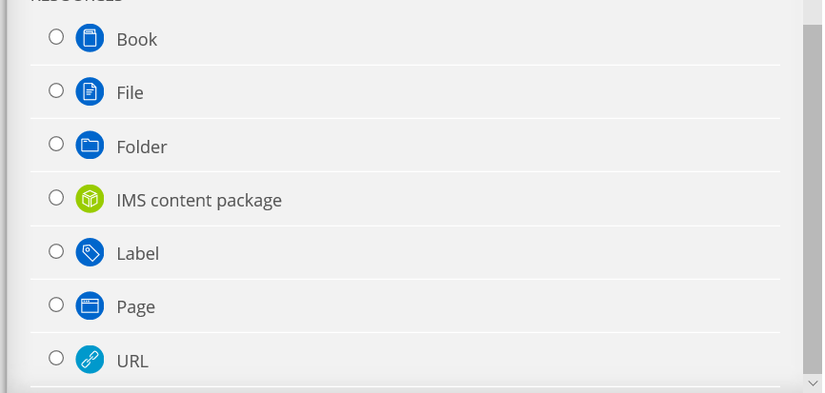

Also we can add:

* A quiz (that we showed about how it works)
* A SCORM package

